3D CG & Animation
2/15/11

A Shareware Spline Modeler with VRML & RIB Export

We shall spend some of this class finding and using a simple, freely available, 3D modeling program called sPatch. You can download this from our class directory on Data, the website, or:
http://www.eatonhand.com/images/spatch.htm
—a makeshift repository for sPatch and hamaPatch (another free spline Windows modeler). Previously there were good tutorials online, but now they are gone.

HELP in sPatch brings up a web browser window with the documentation. (If this doesn't work, open index.html in the docs folder in the sPatch folder.)

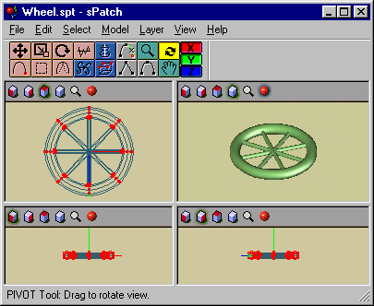

Assignment #4 (due 2/22/11):
1) Build a vehicle in sPatch: it should be a recognizable, possibly useful, “rolling” object with some complexity, but no fine level of detail is required. DO NOT use a model from somewhere else!!
2) Print it in four-view wireframe and in full-screen render (black & white is fine).
3) Export it in VRML, load it into Cortona, and print the picture.
4) Export it in RenderMan, and print the first page of that RIB file.
5) Load the .rib file into BMRT and print the picture (to be discussed).

