Math Encounters
at the de Young Museum

FAMSF and The Fusion Project

by Benjamin Wells
and the Fusion Project Teachers Advisory Group:
Bob Giambruno, John Hagen, Claire Potter, Gail Purtell, and Carlos Trujillo
with the editorial assistance of Doris Schattschneider

© 2008, 2009, 2013 Benjamin Wells
Departments of Mathematics and of Computer Science
University of San Francisco
Math Encounters at the de Young Museum
FAMSF and The Fusion Project

Introduction

Middle School students most often see mathematics as numbers and symbols in a text, on a board, or on a test—they are expected to manipulate or calculate to get an answer. Rarely is math connected to real encounters in students’ lives. The math encounters in this collection are designed to engage students in finding math in an unlikely place—at an art museum.

Students are asked to examine, count, measure, estimate, draw, calculate, and explain as they examine works of art and elements of architectural design at the de Young Museum. Some lessons are designed for the classroom to prepare for a visit, or to follow up on a visit. Others are designed to guide students to ask and answer questions while at the museum. If a class visit is not always possible, there are “virtual visit” lessons as alternatives to actual visits.

The topics and skills that are addressed in these encounters are all from the middle school curriculum. They were chosen because they are among those least well understood by students, as measured by standardized tests, and because they also can be found in the artwork and architectural design of the de Young Museum.

The lessons in the encounters have been developed to enhance and support the lessons found in middle school math textbooks, to engage students in a non-math environment, and to provide an interdisciplinary connection between math and art/design. They can be used in various ways, including
- as a basic, somewhat interventional, approach to math topics that have probably not been well supported by learning in earlier grades;
- in a solid 7th grade math survey, and usable by higher grades as well, especially in relation to the California High School Exit Examination (CAHSEE);
- as an enrichment program for classes (even in higher grades) that may have solid background for the standards but wish to go beyond them.

A more detailed rationale for these math encounters can be found in Appendix 1. There you will find a list of the Seventh Grade Standards for Mathematics, with those that are key standards (Mathematics Framework for California Public Schools) specially noted. We identify our “target standards,” those in which students performed most poorly, based on sample test data. We also identify which of the target standards are addressed directly or indirectly by this collection of encounters. Standards and artwork specific to the sample Encounter 3 included here are listed in Appendix 2. Appendix 3 describes the structure suggested to the Teachers Advisory Group.

We note that each of the Math Encounters is independent of the others; they can be used in any order. The order in which they appear is linked to the numerical order of the standards they principally address. Each Math Encounter makes clear the math background that is necessary for the lessons.
The authors

Benjamin Wells is a professor in the Mathematics and Computer Science Departments at the University of San Francisco; he is the Director of Education for the Fusion Project.

Bob Giambruno is a retired middle-school math teacher living in San Francisco.

John Hagen is a former software developer who decided to teach secondary school math. He is currently teaching at Pinewood School, a private K-12 school in Los Altos.

Claire Potter teaches middle-school mathematics at St. Hilary School in Tiburon.

Gail Purtell teaches mathematics at Altamira Middle School in Sonoma.

Carlos Trujillo has been a middle-school math teacher at St. Philip Neri School in Alameda; he has also taught high school students in UC Berkeley preparation courses. He is now returning to graduate studies.

Doris Schattschneider is Professor Emerita of Mathematics, Moravian College, Bethlehem PA, the first woman editor of Mathematics Magazine, and the author of numerous books on geometry, symmetry, and the work of M. C. Escher.
Notes on using the Math Encounters

This section will be written after a common format is agreed upon for all the encounters. It will combine information sent to the Teachers Advisory Group on lesson development and advice to teachers found in each section of the Math Stories document. All advice that is common to all lessons (for example, working in teams of two or three students) will go here to avoid tedious duplication. Only instructions/advice for an “encounter” that is specific to that lesson will be put into that lesson.

Example notes:

- Some of the standards focus on graphical representation. That may mean on graph paper, but it is also interpreted here as meaning visual representation.
- Works of art for each story are grouped in Main and Additional categories. There may be others that should be added, but in most cases, both groups can be reduced without harm.
- The stories are ordered by the numerical order of the standards they principally address, not by their intrinsic interest (which is probably the reverse order).
- It is hard to imagine motivating every student with this material, so the best approach is to use teams and small groups. This will work well in the classroom but be particularly useful onsite.
- Visiting classes should plan strategies in advance to maximize coverage onsite. Two or three stories per visit seems likely. On the other hand, it may prove helpful to develop the curriculum so all 7 stories are used, with many fewer works involved and a focus only on the target standards. In that case, an appendix could introduce more works and more standards.
- Equipment needed by each student or pair-team: gridpaper pad and pencil, tape measure, ring & string (a snapring on a string to determine a vertical for measurement)
- Calculators: these should be optional; simple calculations should be done on paper. Roots of nonsquare integers will require a calculator, although some problems might address estimation without a calculator.
- With socially and politically loaded works (such as The Burning of LA, Anti-Mass and The Meat Market), the teacher/guide must be certain not to marginalize the content in favor of the mathematical structure of the composition.
- The staircases (even the missing spiral one) can be replaced by ones at school till the field trip to the de Young Museum.
- The more evanescent works (in the Saxe Gallery for instance) are listed near the end, and prints from the ImageBase and 4D (LeWitt, Escher, perspective) are listed last. The prints would only be used at school, or posters might be provided at the museum for access by teachers or guides.

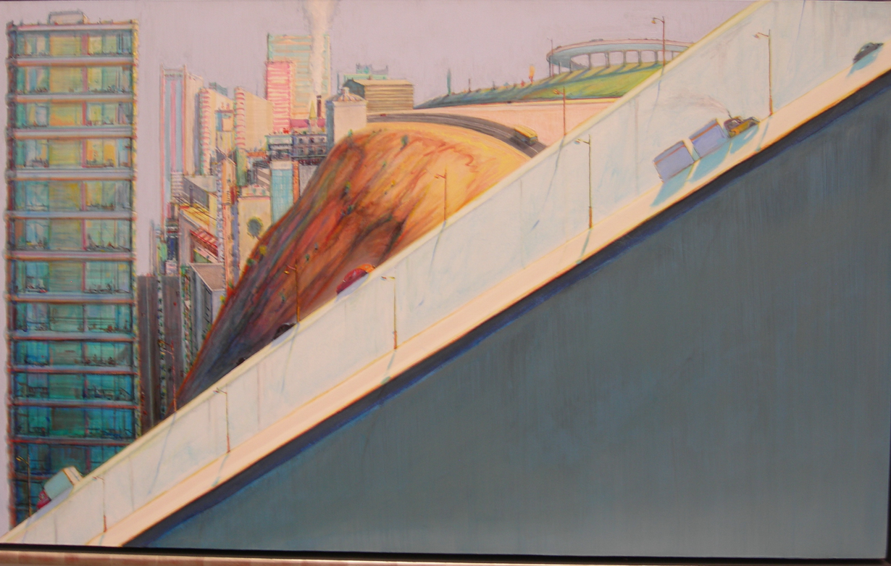

Math Encounter 3. Lines, slope, intercepts, equations, and ramping up

There are many paintings in the de Young Museum that have lines or suggestions of lines that the artist has included to draw our eye to a focal point, or to have us look at a scene from a special angle. The museum also has several staircases; some are easier to walk up than others—their steepness, or pitch, makes them easier or harder to climb. We can describe how lines appear in a painting by their slope, and can calculate this by measuring. To understand the pitch of a staircase, we have to imagine it replaced by a ramp, and then calculate the slope of the ramp. (Some staircases, like the main staircase to the second floor have varying pitch, depending on where you tread. These stairs are steeper along one edge than the other, and neither is as steep as at the center banister.)

Concepts and skills addressed: measuring slope, estimating slope, graphing lines, making scale drawings of staircase sections, moving from ramp parameters (rise, run, start, end) to equations of lines and to algebraic parameters (slope, intercepts, intersections). (See end of lesson for a list of specific standards addressed.)

Outline of Encounter 3
by Claire Potter

There are three class lessons; each should take one class period. In addition, there are activities specifically for a visit to the de Young museum. An extra period for further exploration and for review is suggested.

Lesson 1: Discovering Slope.
Students determine the slope of a line: by measuring; from the graph of the line in a coordinate plane; and from a given pair of coordinates of points on the line.

Lesson 2: Discovering the Slope-Intercept Form.
Students determine the y-intercept of a line in a coordinate plane and discover the slope-intercept form of a linear equation. In doing so students will recognize that the line is a set of points whose coordinates represent solutions to linear equations.

Lesson 3: Determining the Slope-Intercept Form.
Students examine new art works and determine the slope-intercept form of lines.

Activities at the Museum
Students determine pitch of stair steps, estimate slopes of lines in some art works, find artworks in which certain grids of lines occur, see originals of art works studied (or to be studied) in class.

Materials Needed
For students: For all three lessons, each student group will need an authorized reproduction of each of the selected art works to be examined (black and white copies will suffice). Each group will need a transparent coordinate grid with marked centimeter units. (Alternative: Photocopy the art works with the transparent Cartesian coordinate grid superimposed.) Each student should have a copy of any worksheets
for the lesson.
For teachers: Poster-sized reproductions of selected art works, or an overhead projector on which to project transparencies of the reproductions of the selected works. Transparencies of the selected works (at the same scale as the student reproductions), and a transparent Cartesian coordinate grid with marked centimeter units. Transparencies of the tables on the worksheets (for discussing and checking student results). If a computer projector is available, the art works (and gridded art works) may be projected directly from the CD.

Prerequisites for Students. Students should
• be familiar with the Cartesian coordinate system and its vocabulary;
• know how to plot points and identify coordinates of points (ordered pairs of real numbers);
• know how to list signed numbers in order from lowest to highest; and
• know the rules for division of signed numbers.

Introduction to Slope as found in art (optional)

Display an overhead transparency or large copy of Gustav Grunewald’s Horseshoe Falls from below the High Bank and The Niagra River at the Cataract to begin a discussion about slope.

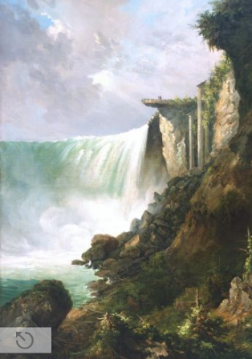
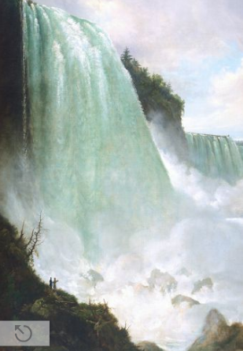

- Where does your eye go when you look at these works?
- How did the artist make you look that way?

Note the gradual “flattening” of the lines as you move from left to right in Horseshoe Falls; the horizontal line between one work and the next; and finally the gradual increase of steepness of the lines as you move from left to right in Niagra River.

This pair of works can be used to discuss the difference between positive and negative slope, slopes with absolute value greater than 1 or less than 1, and a slope of 0.
Sample Lesson—Lesson 1: Discovering Slope.

Art works studied: Sol LeWitt: Lines from Points to Points, plate 4; Squares with a Different Line Direction in Each Half Square, plate 10; and Lines to Specific Points, plate 1.

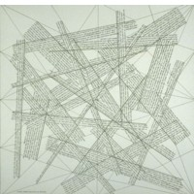
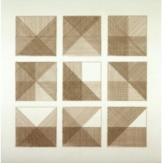
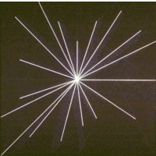

Part 1: Guided discovery.

Distribute the picture Lines from Points to Points to student groups and also the worksheet titled Discovering Slope.

Have students examine the picture and answer questions 1 and 2 on the worksheet. You may wish to have them report answers and check for accuracy before continuing to question 3.

Go over the definition of slope (this is on the worksheet)

For question 3, demonstrate how to calculate slope of a segment by filling in the first two rows of the table with the class. Superimpose the transparent coordinate grid on the picture so that one pair of intersecting grid lines lies on the vertical and horizontal edges of the picture. Then another pair of grid lines will form a right triangle with the segment as the hypotenuse. The legs of this right triangle can be used to determine the rise and run of the segment to the nearest whole centimeter. (Or, use a transparency of the picture with the coordinate grid already superimposed.) For at least one line, demonstrate that the same slope results for two points whether you move from right to left or from left to right in determining the rise and the run.

Review the rules of division of signed numbers: the ratio of two numbers with the same sign is a positive number; the ratio of two numbers with opposite signs is a negative number; division by zero is undefined.

Have students (with their groups) complete the table for the rest of the line segments, in the manner demonstrated.

Discuss and check student calculations and conclusions about positive and negative slope and about those with absolute value less or greater than one.

Part 2: Students on their own

Distribute Squares with a Different Line Direction in Each Half Square to student groups and have them examine the picture. This work has several lines with slope 1, –1, 0 (horizontal lines have 0 rise), and undefined slope (vertical lines have 0 run).

Have students calculate slopes as done in Part 1, filling in Table 2. Discuss and check results.

Part 3. Closure and Extension/Assessment

Students should calculate the slopes of all the segments in LeWitt’s Lines to Specific Points.

Here are some additional ideas for extension.
• These studies about slope can lead to practical representations of Pythagoras’ Theorem and computing missing parts of right triangles.

• LeWitt’s pieces lend themselves to reimplementation and elaboration. Students may find it fun to make this sort of art.
Sample Worksheet: Discovering Slope
by Claire Potter and Doris Schattschneider

Part 1.
Examine the picture by Sol Lewitt called Lines from Points to Points. Several of the thick lines in the picture are labeled with letters.

1. Which labeled lines slope upwards from left to right? List them: ______________________

Which labeled lines slope downward from left to right? List them: _______________________

2. In your list of upward sloping lines, which line is the steepest? ________
Which line is the most flat? __________
Now sort these lines according to steepness, with the most flat first, and list them in order by letter:
________________________________________________

In your list of downward sloping lines, which line is the steepest? ________
Which line is the most flat? __________
Now sort these lines according to steepness, with the most steep first, and list them in order by letter:
_________________________________________________

Definition: The slope of a line is the ratio of the vertical change to the horizontal change as you move from one point to another along the line.

Note that as you move along the line from one point to another, if you move up, the vertical change is positive and if you move down, the vertical change is negative. The vertical change is called the “rise” and is the numerator of the ratio. As you move along the line from one point to another, if you move to the right, the horizontal change is positive and if you move to the left, the horizontal change is negative. The horizontal change is called the “run” and is the denominator of the ratio.

3. For each of the labeled line segments in the picture, use the coordinate grid superimposed on the picture to measure vertical and horizontal change between two points on the line where a grid line intersects the line. Your teacher will demonstrate how to do this. In measuring vertical and horizontal change, round your measurements to the nearest centimeter, and remember to include the sign of the change.

Fill in Table 1 with your measurements, and use them to calculate the slopes of the lines.

Line  Segment | horizontal change | vertical change | slope = vertical change  horizontal change
a | (demonstrated) | (demonstrated) | (positive)
b | (demonstrated) | (demonstrated) | (negative)
c
d
TABLE 1

[table will list all labeled lines—there should be no more than 8]

The signed numbers in the slopes column of Table 1 are not listed in increasing order. In the first row of the table below, list these signed numbers in increasing order, and in the second row, give the labels of their corresponding lines.

slope
line

How does the list of labels of lines in this table compare with the lists you made in question 2?

How can you recognize lines with negative slope?

How can you recognize lines with positive slope?

How can you recognize lines where the absolute value of the slope is less than one?

How can you recognize lines where the absolute value of the slope is greater than one?

Part 2.
Examine the picture by Sol Lewitt called Squares with a Different Line Direction in Each Half Square.
Find the slopes of each of the labeled lines in this picture. Use the same technique that you used to calculate slopes in Part 1. Use Table 2 below to record your calculations.

Line  Segment | horizontal change | vertical change | slope = vertical change  horizontal change
a
b
c
d, etc.
TABLE 2

Part 3.
Examine the picture by Sol Lewitt called Lines to Specific Points.
Find the slopes of each of the labeled lines in this picture. Use the same technique that you used to calculate slopes in Part 1. Use Table 3 below to record your calculations.

Line  Segment | horizontal change | vertical change | slope = vertical change  horizontal change
a
b
c
d, etc.
TABLE 3
Appendix 1

Rationale for Math Encounters at the de Young Museum

Seventh Grade Standards for Mathematics

These 46 standards are summarized from California High School Exit Examination (CAHSEE) documents. They include 40 seventh grade standards from STAR documents plus 6 additional Mathematical Reasoning standards. They are coded as follows: NS for Number Sense, AF for Algebra and Functions, MG for Measurement & Geometry, PS for Probability and Statistics (note that no 7th grade standard involves probability), and MR for Mathematical Reasoning. In developing “Math Encounters”, target standards were identified from this list. These were the ones on which students performed most poorly, based on sample test data. The high target standards are those that appeared most often in missed questions and are labeled by bold type. In addition, * denotes key standards (Mathematics Framework for California Public Schools).

All standards
1 NS1.1 Read, write, compare, approx.: rational numbers in scientific notation
2 NS1.2* +,×,-,/ rational numbers (ints, fracs, & term dec; (a/b)^m
3 NS1.3 Convert fracs to decs and %s; use in est, comp, applics
4 NS1.4* Differentiate between rational and irrational numbers.
5 NS1.5* Know every rati is either a terminating or repeating dec; term->rat
6 NS1.6 Calculate the percentage of increases and decreases of a quantity.
7 NS1.7* Solve probs on discount, markup, commission, profit; s & c interest
8 NS2.1 Understand negative whole-number exps. ×,/ exp w/comm base
9 NS2.2* Add and subtract fractions by factoring to find common denoms.
10 NS2.3* Multiply, divide, and simplify rational numbers by using exp rules.
11 NS2.4 Power/root of square ints; other roots between 2 ints.
12 NS2.5* abs val, distance on number line; calc abs val
13 AF1.1 Use var, ops to write expr, eqn, ineq, sys eqn/ineq to verbal desc
14 AF1.2 Use order of ops to eval alg exprns such as 3(2x + 5)^2.
15 AF1.3* Simplify num exprs by applying laws of ratl numrs (assoc ++)
16 AF1.4 Use algebraic terminology (e.g., va, eqn, term) correctly.
17 AF1.5 Represent quant rels graphically; interpret part of graph
18 AF2.1 Interpt +int powers as repeated ×, -int as /; simp, eval exprs w/exps.
19 AF2.2 ×, / monomials; take powers and whole roots.
20 AF3.1 Graph functions of the form y = nx^2 and y = nx^3; solve problems.
21 AF3.2 Plot 3D vols as fcn of edge length, base edge length.
22 AF3.3* Graph linear fcns; note ∆y is same for given ∆x; rise/run = slope.
23 AF3.4* Plot quants whose ratios are constant (ft/in); fit line, interpret slope.
24 AF4.1* Solve 2-step lin eqns & inequalities in 1 var over the rats; interp.
25 AF4.2* Solve multistep problems involving rdt and dir variation.
26 MG1.1 Cf. & convert wts, caps, geom measures, times, and temps
27 MG1.2 Construct and read drawings and models made to scale.
28 MG1.3* Use measures expressed as rates & prods; use dim anal to check.
29 MG2.1 Use fmls to find perim & area of 2-3D: tri, quadril, circ, prisms, cyls
30 MG2.2 Estim & compute area of complex 2-3D figs by decomp.
31 MG2.3 Comp perim, sa, vol of 3D objs from rect solids; scaling vol, sa.
32 MG2.4 Relate the scale changes in measurement to units and conv.
33 MG3.1 Identify, construct c+se geom figs (alts, mp, diag, bisects, circs)
34 MG3.2 Coord graphs to plot simple figs; detmn ln, area; trans/refl image
35 MG3.3* Pyth thm and converse; appls; exper verif by measuring.
36 MG3.4* Conditions for congruence (general); meaning for sides, angles
37 MG3.6* Elems of 3D objs; skew lines; 3-plane intersections
38 PS1.1 Var disp of data sets; stem&leaf; box&whisker; cf. 2 datasets
39 PS1.2 2 num var on a scatterplot; informal descrp of dist and reln.
40 PS1.3* Know, comp. min, LQ, median, UQ, max
41 MR1.1 Anal. probs from relns, rel/irrel, missing info, patterns
42 MR1.2 Formulate & justify math conjectures based on a general descrp
43 MR2.1 Use estimation to verify the reasonableness of calculated results.
44 MR2.3 Estimate unknowns graphically; solve by using logic, arith, alg.
45 MR2.4 Make & test conjectures using both inductive & deductive reasoning.
46 MR3.3 Generalize results and strats and apply in novel problem sits.

Target standards; all of these are addressed in one or more of the Math Encounters
2 NS1.2* +,×,-,/ rational numbers (ints, fracs, & term dec); (a/b)^m
6 NS1.6 Calculate the percentage of increases and decreases of a quantity.
9 NS2.2* Add and subtract fractions by factoring to find common denoms.
14 AF1.2 Use order of ops to eval alg exprns such as 3(2x + 5)^2.
15 AF1.3* Simplify num exprs by applying laws of ratl numrs (assoc ++)
17 AF1.5 Represent quant rels graphically; interpret part of graph
22 AF3.3* Graph linear fcns; note ∆y is same for given ∆x; rise/run = slope.
23 AF3.4* Plot quants whose ratios are constant (ft/in); fit line, interpret slope.
24 AF4.1* Solve 2-step lin eqns & inequalities in 1 var over the rats; interp.
25 AF4.2* Solve multistep problems involving rdt and dir variation.
33 MG3.1 Identify, construct c+se geom figs (alts, mp, diag, bisects, circs)
34 MG3.2 Coord graphs to plot simple figs; detmn ln, area; trans/refl image
37 MG3.6* Elems of 3D objs; skew lines; 3-plane intersections
41 MR1.1 Anal. probs from relns, rel/irrel, missing info, patterns
44 MR2.3 Estimate unknowns graphically; solve by using logic, arith, alg.
45 MR2.4 Make & test conjectures using both inductive & deductive reasoning.

Additional standards involved in the encounters or their extensions (those close to target standards are italicized):
7 NS1.7* Solve probs on discount, markup, commission, profit; s & c interest
13 AF1.1 Use var, ops to write expr, eqn, ineq, sys eqn/ineq to verbal desc
16 AF1.4 Use algebraic terminology (e.g., va, eqn, term) correctly.
21 AF3.2 Plot 3D vols as fcn of edge length, base edge length.
27 MG1.2 Construct and read drawings and models made to scale.
28 MG1.3* Use measures expressed as rates & prods; use dim anal to check.
35 MG3.3* Pyth thm and converse; appls; exper verif by measuring.
36 MG3.4* Conditions for congruence (general); meaning for sides, angles
38 PS1.1 Var disp of data sets; stem&leaf; box&whisker; cf. 2 datasets
40 PS1.3* Know, comp. min, LQ, median, UQ, max
42 MR1.2 Formulate & justify math conjectures based on a general descrp
43 MR2.1 Use estimation to verify the reasonableness of calculated results.
46 MR3.3 Generalize results and strats and apply in novel problem sits.

Standards close to being target standards and not addressed by Math Encounters:
10 NS2.3* Multiply, divide, and simplify rational numbers by using exp rules.
11 NS2.4 Power/root of square ints; other roots between 2 ints.
12 NS2.5* abs val, distance on number line; calc abs val
18 AF2.1 Interpt +int powers as repeated ×, -int as /; simp, eval exprs w/exps.
19 AF2.2 ×, / monomials; take powers and whole roots.

Remaining standards not addressed by Math Encounters:
1 NS1.1 Read, write, compare, approx.: rational numbers in scientific notation
4 NS1.4* Differentiate between rational and irrational numbers.
5 NS1.5* Know every rati is either a terminating or repeating dec; term->rat
8 NS2.1 Understand negative whole-number exps. ×,/ exp w/comm base
20 AF3.1 Graph functions of the form y = nx^2 and y = nx^3; solve problems.
26 MG1.1 Cf. & convert wts, caps, geom measures, times, and temps
32 MG2.4 Relate the scale changes in measurement to units and conv.
39 PS1.2 2 num var on a scatterplot; informal descrp of dist and reln.

Because Mathematical Reasoning standards are overarching and not independent of content, there are no problems that address them directly. In a similar way, specific applications for them are not suggested in these materials. They will be apparent from the questions asked.

Appendix 2

Math Encounter 3:
Lines, slope, intercepts, equations, and ramping up

Standards and Works of Art

The high target standards are those that appeared most often in missed questions and are labeled by bold type. In addition, * denotes key standards (Mathematics Framework for California Public Schools).

Target standards principally addressed by this encounter:
17 AF1.5 Represent quant rels graphically; interpret part of graph
22 AF3.3* Graph linear fcns; note ∆y is same for given ∆x; rise/run = slope.
23 AF3.4* Plot quants whose ratios are constant (ft/in); fit line, interpret slope.
24 AF4.1* Solve 2-step lin eqns & inequalities in 1 var over the rats; interp.
25 AF4.2* Solve multistep problems involving rdt and dir variation.

Other target standards addressed by this encounter:
2 NS1.2* +,*,-,/ rational numbers (ints, fracs, & term dec); (a/b)^m
15 AF1.3* Simplify num exprs by applying laws of ratl numrs (assoc ++)
33 MG3.1 Identify, construct c+se geom figs (alts, mp, diag, bisects, circs)
41 MR1.1 Anal. probs from relns, rel/irrel, missing info, patterns
44 MR2.3 Estimate unknowns graphically; solve by using logic, arith, alg.
45 MR2.4 Make & test conjectures using both inductive & deductive reasoning.

Additional standards involved in this encounter or its extensions:
16 AF1.4 Use algebraic terminology (e.g., va, eqn, term) correctly.
27 MG1.2 Construct and read drawings and models made to scale.
28 MG1.3* Use measures expressed as rates & prods; use dim anal to check.
35 MG3.3* Pyth thm and converse; appls; exper verif by measuring.
42 MR1.2 Formulate & justify math conjectures based on a general descrp.
46 MR3.3 Generalize results and strats and apply in novel problem sits.

Main Works:
staircases
Diagonal Freeway
Igbo Door
From the Garden of Chateau
Study of Architecture in Florence

Additional Works:
Feather tunic
Terrace overhangs/Mondrianic shadows
Shadow Frieze
Pl. 10 from the set, Squares with a Different Line Direction in Each Half Square
Lines to Specific Points, plate 1
Lines From Points to Points, plate 4
copper skin
perspective plates
Appendix 3

The Structure of a Math Encounter

Here is the description of for the instructional enhancement material to amplify each of the Seven Stories. In each of the stories, there is room for innovation on this structure, but these are the primary goals:
- Interest and attractiveness—teachers should be able to imagine using the material and immediately see how they could work with it, and even better, improve it.
- Clarity—teachers (and their students) must see concrete suggestions, even if they are about abstract concepts; there must be no handwaving, jargon, glibness, cuteness, smugness.
- Consistency—these materials have been prepared by a committee, and it is our determination not to edit away all individuality; after all, this is an appeal to individual teachers to catch hold for the ride; in the end, though, there has to be a steady rhythm in the presentation and the tasks. The variation in art, story, and math will add to the natural variety. A visible and useful structure can provide the consistency.
- Focus—our primary aim is the improvement in mandated and identified standards. We want students to do better on standardized tests, but we want them to improve through interest, not drill. Beyond that, we automatically offer enrichment, variety, and innovation. Teachers looking for that will see it easily. We do not need to go into detail, but we need to indicate that this is not (or not merely) an opportunity for more drill.

Here is an outline of a Math Encounter:
- Justification of story by art and target standards
- Examples of core cycles
- Trajectories.
- Equipment/materials needed.
- Recommended activities
- Worksheets
- Assessment
- Extensions and suggestions

Foremost in this structure is the core cycle. It is suggested in more detail below. Briefly, it places an art-problem first, ringing a clear bell of innovation and connection with art and the museum's collection. It moves to a purely math-driven problem (partly in homage to recent research* showing that students actually learn better with abstract patterns than with concrete ones—although there are contrary opinions). It ends with an art-problem, completing the wrapper. It limits the concepts and techniques to what are needed just here, while leaving it open to reiteration and expansion in additional cycles. Ideally, each encounter should include three core-cycle examples, with enough art, extensions, and suggestions to allow teachers to make up three more. The core cycle is a basic idea of flow, not a replacement for a lesson plan.

Trajectories: we can offer one or two routes through the material. For example, one path can feature an early museum visit, with just a bare introduction, then build on the experience of the visit in the classroom for a week or a month (at regular intervals). Another can emphasize thorough working in class ending with a visit to the museum as a consolidation and reward, finally seeing the art that has been well studied already. A particular trajectory might be specified as offering one core cycle in class, a pre-musuem activity, a museum visit, a post-museum activity, and five more core cycles in class.

Equipment/materials needed
- At the museum:
  - clipboard—cannot use cabinets or stands to help write
  - gridpaper
  - pencil—museums traditionally are antsy about ink (SFMOMA guards supply pencils to get you to put away a pen)
  - specific equipment for the math tasks—eg., plumbob, measuring tape or string, calculator, cellphone camera (this can be useful for certain works/problems, but also may prove helpful for capturing works for later discussion; I imagine most schools prohibit phones, so this is either a relaxation, or an exception to allow them to be turned on, or a recognition that the students have them anyway).
- In the classroom: students can approach reproductions of the artwork and prepare for the museum by contructing math aids that will help with the problem solving.
The Fusion Project will establish a store of gridpaper and pencils (and more?) at the museum that can be accessed with proper identification, in case students forget or run out.

Recommended activities: these include classroom experiences (and home activities) with the art that are not just lecture/discussion/problem solving. Imagination will help here. The crucial activities are those that unfold at the museum—we offer suggestions, but mostly we convey that the museum visit must be well structured and well communicated in advance, so that the fleeting time there is not wasted and so that the students are held in a matrix of manageability. Chaperones (who must also be informed) are always the key to constructivity and focus. Home activities should be invented as well—it will help to involve parents, who may be chaperones for the museum visit. Keep in mind that there must be some sort of followup to the museum visit; it cannot be the last thing, left hanging. At least one core cycle after the visit, but it may be more appropriate to have a different kind of activity, best generated by the classroom teacher.

Worksheets: Although not every class or teacher will appreciate worksheets at the museum or even for the classroom, we seek to provide suggestions of specific short and open-ended response-type items or an entire sheet, depending on the IEM.

Assessment: Even in colleges, WASC is hot on assessment these days, not to mention the state, etc. This is really your area; suggestions made here merely convey that we are thinking about this without rigidly specifying how to test. Some classes will emphasize reflection by students on their experiences at the museum and in class.

Extensions and suggestions: A number of these are listed in each story sketch, and where teachers find them appropriate, this may be sufficient. Some additional contributions are given in IEMs.

The following steps constitute a Core Cycle

Problem 1 (driven by art)
Concept / Technique A
Concept / Technique B
Concept / Technique C
Application to Problem 1, and refinement

Problem 2 (driven by math)
. . .
Application to Problem 2, and generalization
Alternate or Addition to Problem 2

Problem 3 (driven by art)
. . .
Application to Problem 3, and review

