Math & Art
Spring 2011 Name: ______________________
Computing the Similarity Fractal Dimension

In general, the fractional similarity dimension for a self-similar object A is the ratio

D = log N/log R (this number is often called the fractal dimension),

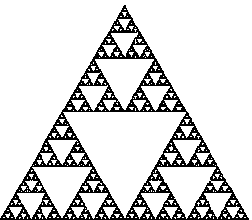
where N is the number of pieces composing A that are actually 1/R-scaled copies of A. (If the scaling factor is, say, 2/3, then R = 3/2; think of R as the “expansion factor” that takes you from the small copy to the original.) Thus the Sierpinski triangle is composed of three half-sized copies of itself:
so its D is log 3 / log 2 = 1.5849... .

And a side of the snowflake is 4 third-sized copies
of itself:or D = log 4 / log 3 = 1.2619... .

The Cantor set comprises two one-third-sized copies of itself:
so its D is log 2 / log 3 = 0.6309... .

Please calculate the similarity dimension of the following objects and return the completed sheet at the next class meeting. You may consult with partners, but please hand in your own work with your own calculations.

1. Equilateral triangle:

2. Sierpinski tetrahedron (early and later stages):

3. Sierpinski carpet (several stages)

4. Menger sponge (make holes through a cube so that each face is a Sierpinski carpet).

5. Cantor square (by stages--note that each side of the square is a Cantor set):

6. Cantor cube (like the Menger sponge, except more is cut out, so that every
face is a Cantor square). Try to sketch it. Give its similarity dimension.

7. Why is this man smiling? 8. How many sides does this shape have?

