USF Fusion Project:
Bridging Middle School Math Classrooms and the Museum
Summer Institute
de Young
Monday – Wednesday June 10-12, 9:00 a.m. – 4 p.m.

Program Description:
The USF Fusion Project (FP) invites all middle school math teachers to apply for our 2013 summer institute. Our staff will show you how to enhance your math classes with practical math activities linked to artwork in the de Young’s permanent collections. The goal of these activities is improvement on California target standards identified by FP as most urgent.

This unique and valuable institute will be held during the June 10-12 at the de Young.

Stipends will be offered to teacher who pilot the developed curriculum in their classrooms during the 2013-14 school year.

For more information please contact:
Emily Jennings, ejennings@famsf.org or 415. 750. 3522.

To apply, please visit: deyoung.famsf.org/education/workshops-educators
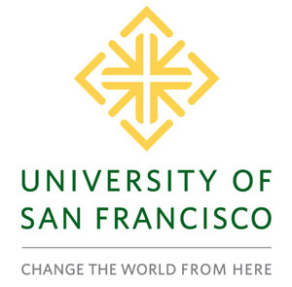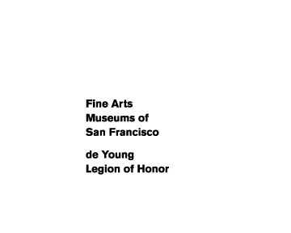

Compensation: $1,000.00 honorarium.

To apply, please contact Emily Jennings by November 1st at ejennings@famsf.org or
415. 750. 3522.

